**Summer Internship Report**



**Online Test Management**

PORUSH GOYAL

17CSU136

August 29, 2019

**Table of Contents**

|  |  |  |
| --- | --- | --- |
| **Sr. No.** | **Name of the Topic** | **Page No.** |
|  | Acknowledgement | 4 |
|  | Abstract | 5 |
|  | Introduction | 6 |
|  | Training Description | 7 |
|  | Introduction to Tools | 10 |
|  | Analysis | 17 |
|  | Conclusion | 18 |
|  | Bibliography | 19 |

**List of Figures**

|  |  |  |
| --- | --- | --- |
| **Sr. No.** | **Figure No,** | **Page No.** |
|  | Fig. 1 | 7 |
|  | Fig. 2 | 8 |
|  | Fig. 3 | 8 |
|  | Fig. 4 | 9 |
|  | Fig. 5 | 9 |
|  | Fig. 6 | 11 |
|  | Fig. 7 | 12 |
|  | Fig. 8 | 13 |
|  | Fig. 9 | 14 |
|  | Fig. 10 | 15 |

**ACKNOWLEDGEMENT**

Industrial Training is an indispensable part of any curriculum. It provides the students with an opportunity to gain experience on the practical application of our knowledge.

This Project report, while an achievement that bears my name, would not have been possible without the help of others. I am glad to take this opportunity to thank the people who helped me to make this work possible.

I express my gratitude to all the people at Hate2wait who helped during the past six weeks. The exposure and experience gained at Maruti has been unique

Firstly, I would like to sincerely thank my mentor **Mr. Ashish Singh**, for his able guidance. He gave me the opportunity to work. His suggestions,

comments were invaluable for this report. In spite of his busy schedule, he patiently listened to my doubts and shared her valuable knowledge.

**(PORUSH)**

**Abstract**

I did my internship at hate2wait, sector 53-54, Gurugram. The goal of the internship was to gain knowledge about web development and to create a career opportunity through it. During my course of internship, I learned to work on Ruby on rails. Under the guidance of my mentor I created a project to manage the creation and deletion of online MCQ tests. As I proceeded, I learned more about MVC, routings and various features of this framework. Through this I was able to learn how real time projects are carried out. Environment there was quite professional, everyone there was best suited for the work they were carrying out. There I got true essence of professionalism, what it means to be a professional and live up to that mark.

**INTRODUCTION**



Hate2wait is building an accurate prediction engine for waiting time that people can use to save their valuable time. Globally, People waste 350 billion hours annually waiting in queues due to uncertainty in waiting times. We strongly believe that we can use technology to build tools to solve this problem and help people save time and frustration and make this world a better place to live in.

We are a mission-driven company with a solid founding team and big ambitions. Hate2wait is growing profitably and exponentially (20X year-on-year revenue growth) over the last 2 years. In the last 2 years, we have helped more than 5 million people save ~230 million mins of waiting time. But our mission is to help 100 million people daily and for that, we want people who want to make this mark with us.

**TRAINING DESCRIPTION**

During my internship I did a project on web Development in which I created a website. The website contained the functionality allowing the user with the role of a teacher to create their own MCQ tests. They would have access to all of their created tests, they can edit, view, delete them whenever the want to. Project also included another role that goes by the name ‘student’. The user who has the role of a student will be able to attempt any of the tests created so far by all of the teachers. Since all of the tests that have been created and all the answers that the student has attempted for a particular test needs to be stored somewhere so the project also deals with the databases. It uses MySql to store all the data.

**Login Page:**

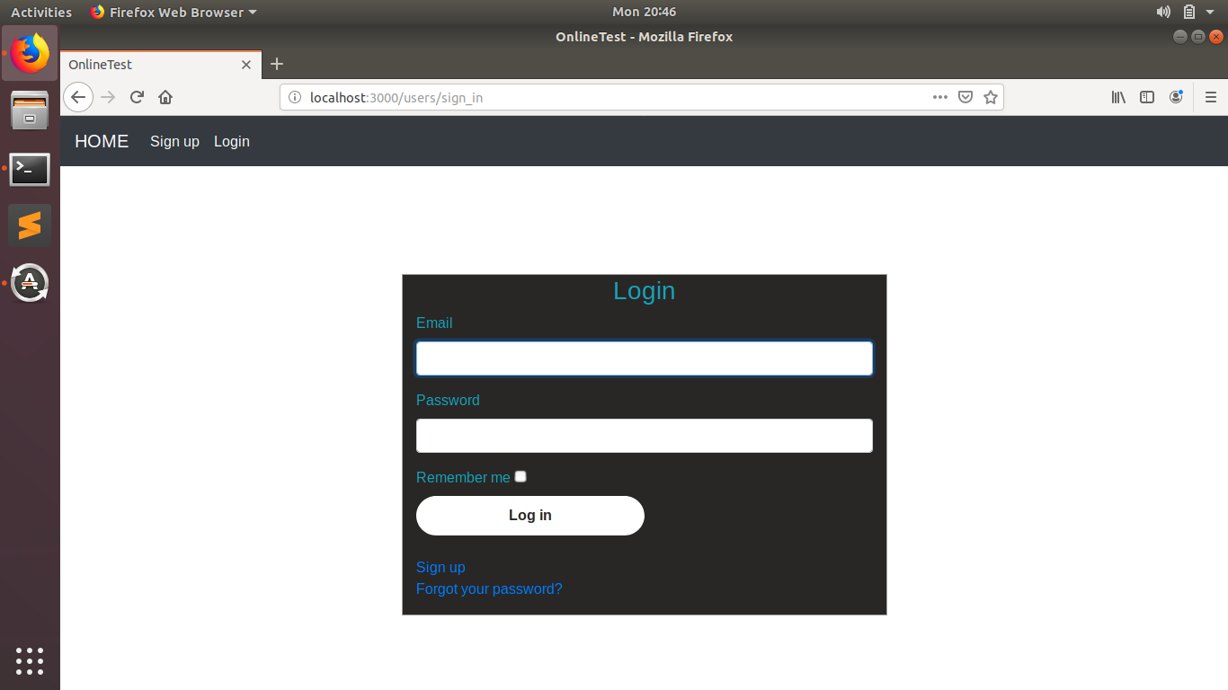

Fig. 1

**Teachers Page:**

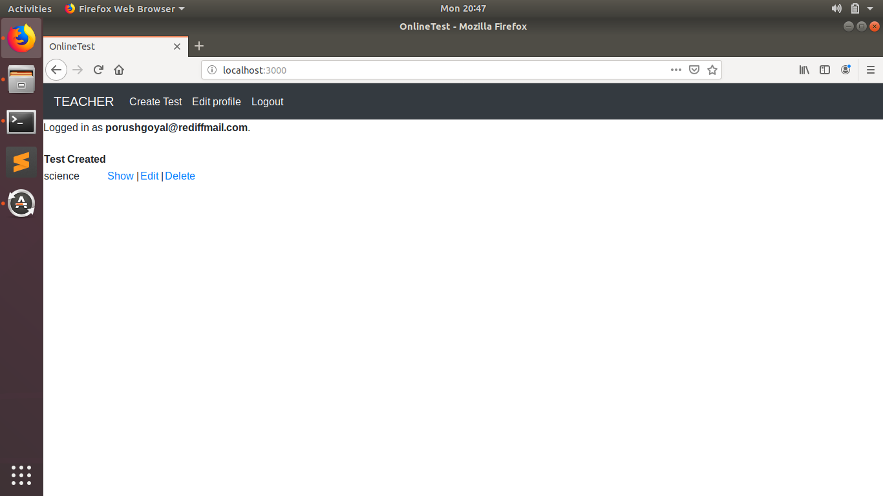

Fig. 2

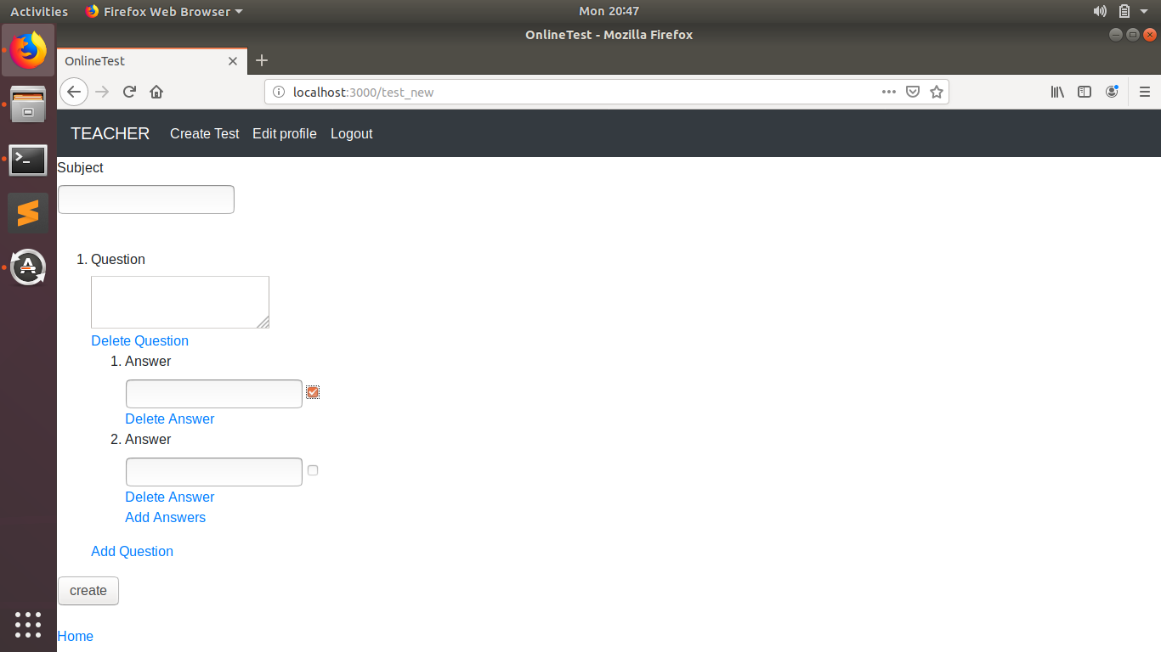

Fig. 3

**Students Page:**

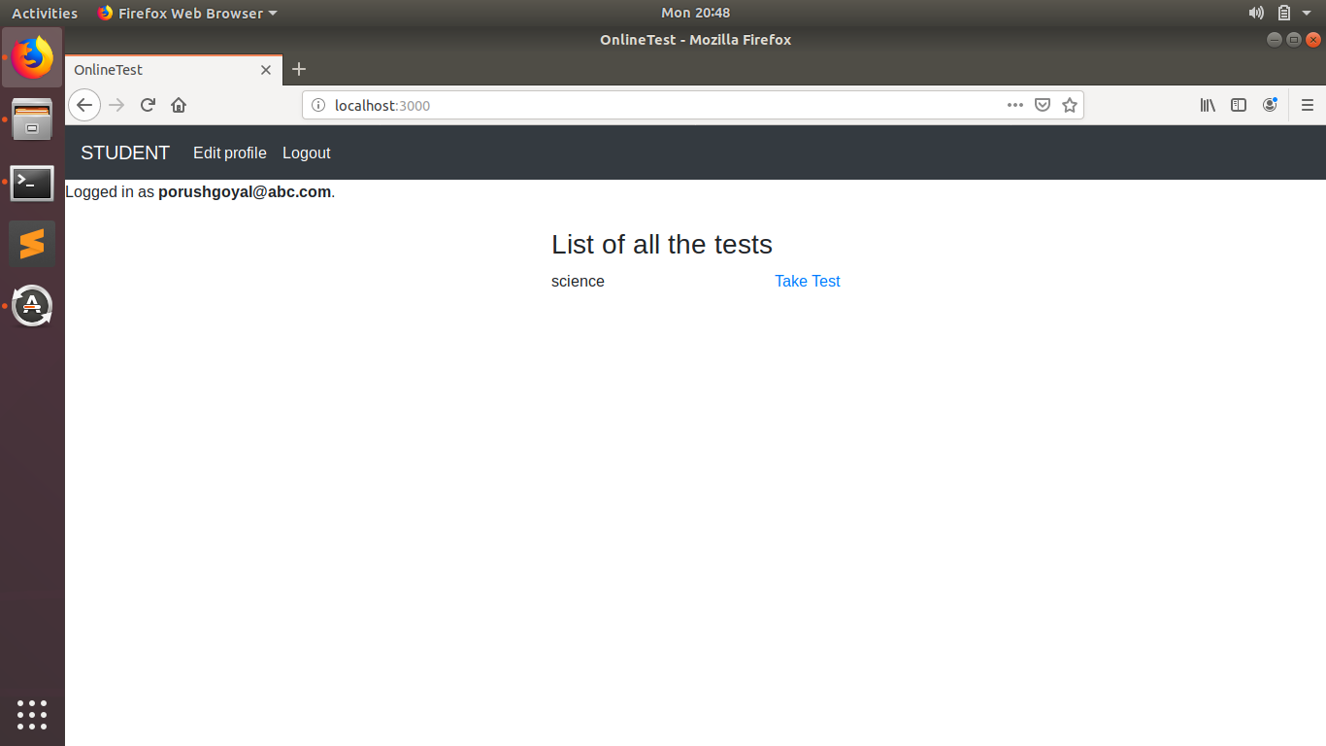

Fig. 4

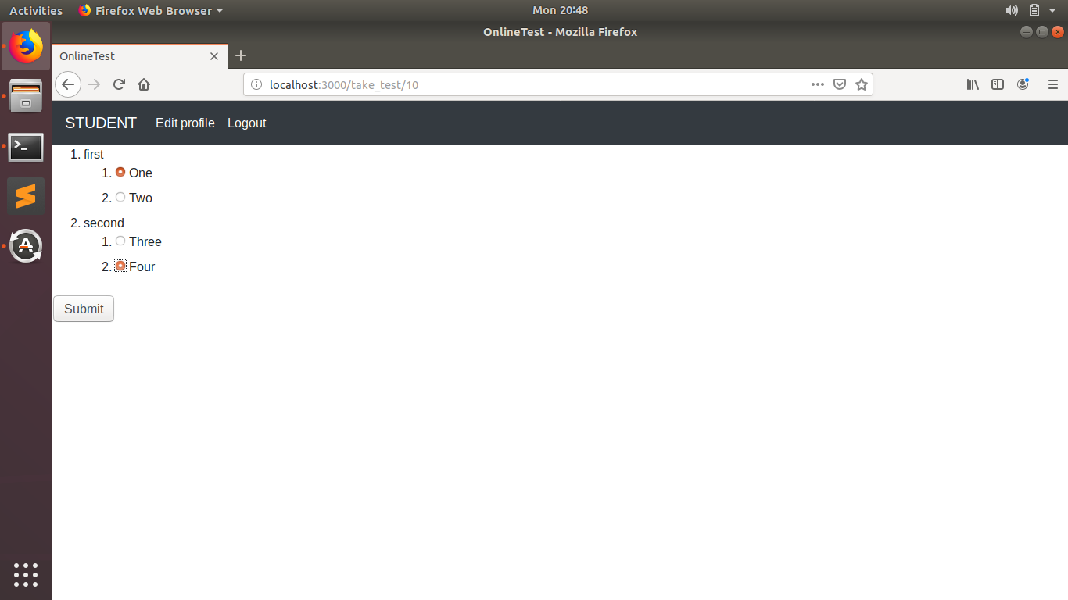

Fig. 5

**Introduction to Tools**

**Ruby on Rails ­**-Ruby on Rails, or Rails, is a server-side web application framework written in Ruby under the MIT License. Rails is a model–view–controller (MVC) framework, providing default structures for a database, a web service, and web pages. It encourages and facilitatesthe use of web standards such as JSON or XML for data transfer, HTML, CSS and JavaScript for user interfacing.

Ruby on Rails' emergence in the 2000s greatly influenced web app development, through innovative features such as seamless database table creations, migrations, and scaffolding of views to enable rapid application development.

**ERB** - ERB templates combine plain text with Ruby code for variable substitution and flow control, making them easy to write and maintain.

The main component of ERB is a library which you can call within your Ruby applications and Rake tasks. This library accepts any string as a template, and imposes no limitations on the source of the template. You may define a template entirely within your code, or store it in an external location and load it as required. This means that you can keep templates in files, SQL databases, or any other kind of storage that you want to use.

**HTML.ERB -** HTML.ERB is HTML mixed with Ruby, using HTML tags. All of Ruby is available for programming along with HTML.

**MODEL –** A Rails Model is Ruby class that can add database record, find particular data you are looking you’re looking for, update that data, or remove that data. These common operations are referred as CRUD.

rails generate model ModelName ColumnOneName:ColumnOneType ColumnTwoName:ColumnTwoType

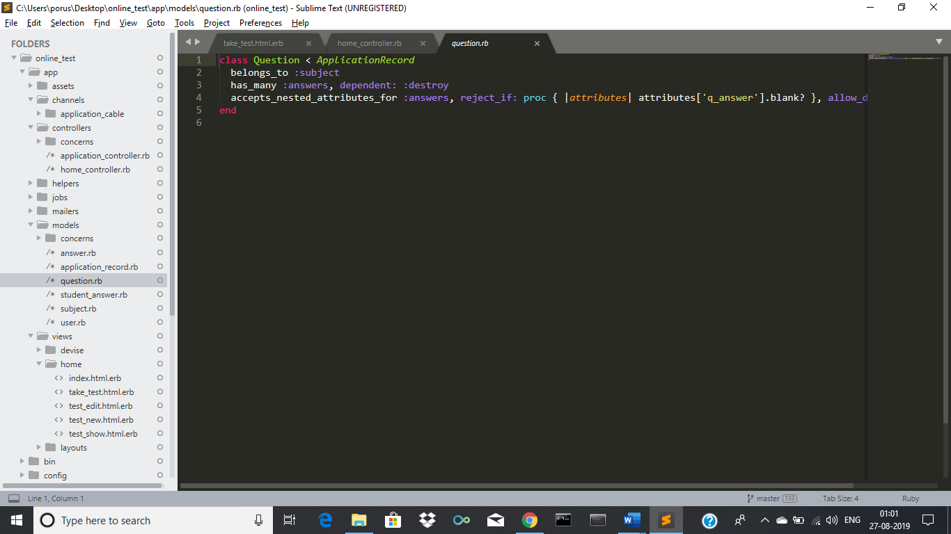

Fig. 6

**VIEWS -** A Rails View is an ERB program that shares data with controllers through mutually accessible variables.

Rails lets you know that you need to create the view file for each new method. Each method you define in the controller needs to have a corresponding ERB file, with the same name as the method, to display the data that the method is collecting.

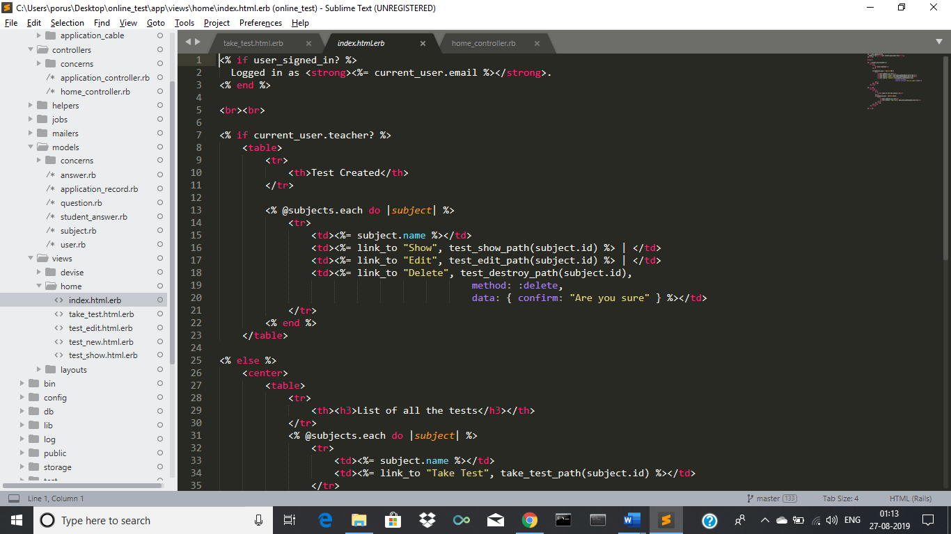

Fig. 7

**CONTROLLER -** A controller is a type of class that’s responsible for making sense out of a request made in an application and producing appropriate output. It acts as the middleman between the views and model. Views are used to display data to the user while models are where you define methods to manipulate data. It communicates with the model to check if request sent is available in the database.

$ bin/rails generate controller controller_name

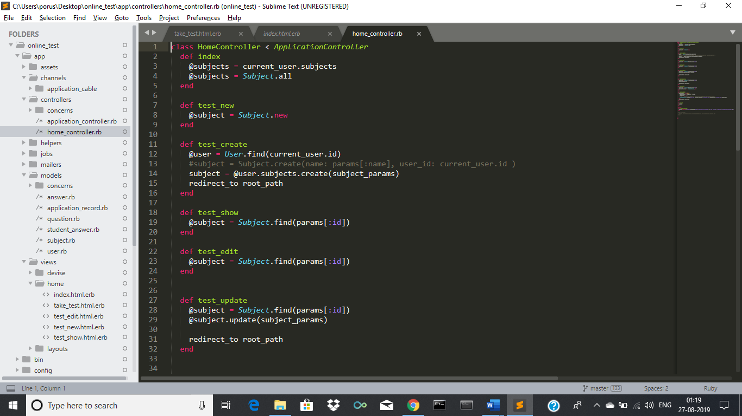

Fig. 8

**ROUTES -** The Rails router recognizes URLs and dispatches them to a controller's action. It also generates paths and URLs. Rails router deals URLs in a different way from other language routers. It determines controller, parameters and action for the request. Basically, a router is a way to redirect incoming requests to controllers and actions. It replaces mod_rewrite rules. One best thing is that, in Rails routing works with any web server. Rails handles routing via config/routes.rb file rather than relying on the web server to control URL routing. This file controls every single aspect of your URLs, like rules that try to match the URL path for a request and decides where to direct that request.

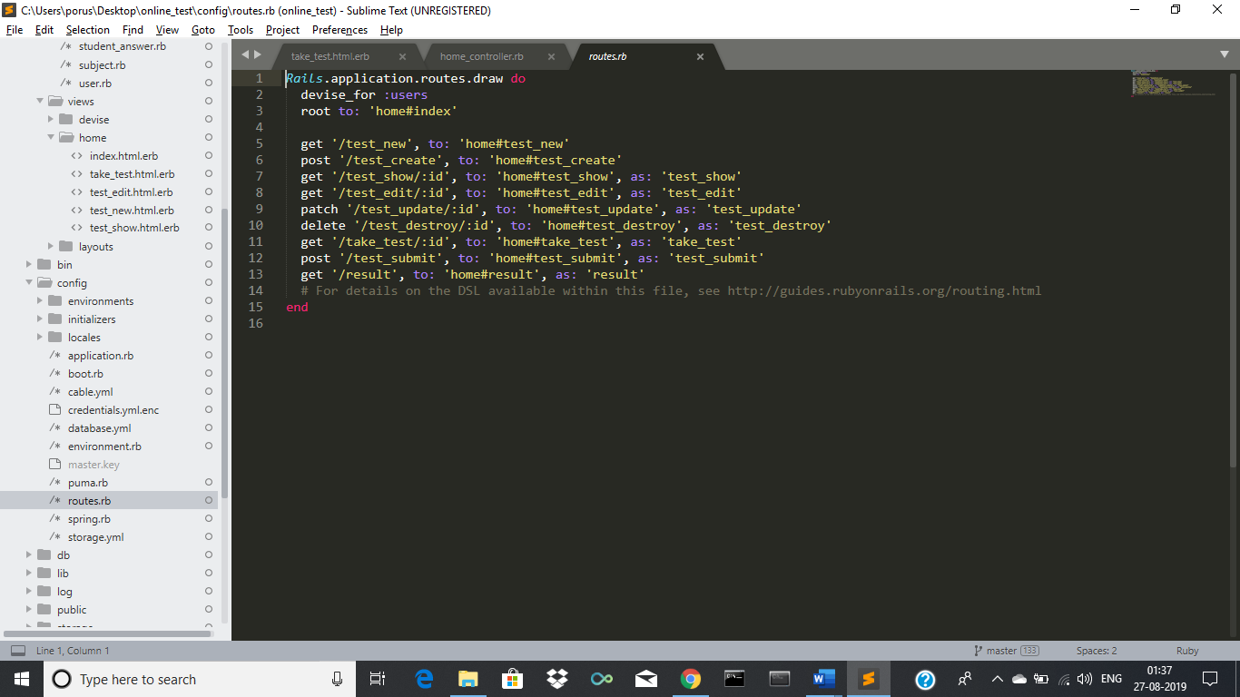

Fig. 9

**MIGRATIONS –** Migrations are a convenient way for you to alter your database in a structured and organized manner. You could edit fragments of SQL by hand but you would then be responsible for telling other developers that they need to go and run them. You'd also have to keep track of which changes need to be run against the production machines next time you deploy.

$ rails db: migrate

**MySQL -** MySQL is an Oracle-backed open source relational database management system ([RDBMS](https://searchdatamanagement.techtarget.com/definition/RDBMS-relational-database-management-system)) based on Structured Query Language ([SQL](https://searchsqlserver.techtarget.com/definition/SQL)). MySQL runs on virtually all platforms, including [Linux](https://searchdatacenter.techtarget.com/definition/Linux-operating-system), [UNIX](https://searchdatacenter.techtarget.com/definition/Unix) and [Windows](https://searchwindowsserver.techtarget.com/definition/Windows). Although it can be used in a wide range of applications, MySQL is most often associated with web applications and online publishing.MySQL is an important component of an open source enterprise stack called [LAMP](https://whatis.techtarget.com/definition/LAMP-Linux-Apache-MySQL-PHP). LAMP is a web development platform that uses Linux as the operating system, [Apache](https://whatis.techtarget.com/definition/Apache) as the web server, MySQL as the relational database management system and [PHP](https://whatis.techtarget.com/definition/PHP-Hypertext-Preprocessor) as the object-oriented scripting language. (Sometimes [Perl](https://whatis.techtarget.com/definition/Perl) or [Python](https://whatis.techtarget.com/definition/Python) is used instead of PHP.)

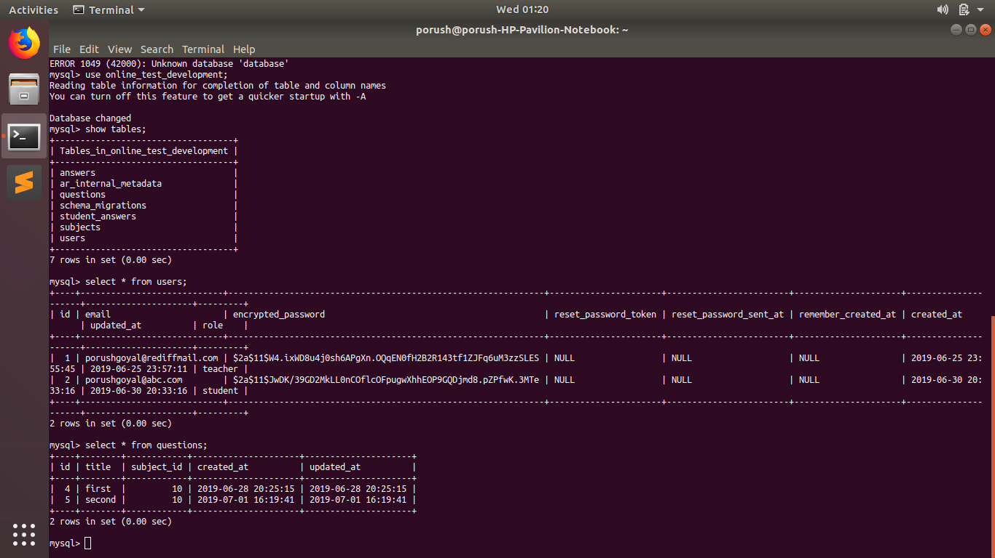

Fig. 10

**CSS – C**ascading **S**tyle **S**heets, fondly referred to as CSS, is a simple design language intended to simplify the process of making web pages presentable.

CSS handles the look and feel part of a web page. Using CSS, you can control the colour of the text, the style of fonts, the spacing between paragraphs, how columns are sized and laid out, what background images or colours are used, layout designs, variations in display for different devices and screen sizes as well as a variety of other effects.

CSS is easy to learn and understand but it provides powerful control over the presentation of an HTML document. Most commonly, CSS is combined with the mark-up languages HTML or XHTML.

**ANALYSIS**

During the past few weeks it’s been a great journey. This internship has been an excellent and rewarding experience. I have been able to meet and connect with many people that I am sure will be able to help me with opportunities in future.

Along my training period, I realized that observation is the major element to find a cause to a problem. Not only for my project but daily activities as well. I worked alongside of IT professionals with decades of knowledge and experience. It was interesting to see how they work and interact with each other. I noticed that all individuals are treated with same respect and appreciation regardless of their position or standing.

Before my internship started my expectations were vastly different than what I actually experienced during my internship. There is a big difference in the school projects and the tasks the activities during the actual work. In school, we learn how to describe the work in projects, where in work you learn how to implement them in reality.

During my internship, I worked under Mr. Ashish from whom I have also learned a lot. Having worked in the field in so many years, he was a constant source of knowledge. I have tried to learn as much as possible from him during my internship.

This internship was definitely beneficial for me and I’m grateful that I got to experience and learn many things.

**CONCLUSION**

During the internship report, I have been exposed to working life of an IT professional. Hate2wait has offered me opportunities to learn and develop myself in many areas. I learned I gained a lot of experience in web development. Being in this company helped me a lot to learn about the IT sector. I have successfully implemented the knowledge that I have gained to make this project. Overall, my internship at Hate2wait has been a success. I was able to gain practical skills and work in a fantastic environment. I could not be more thankful.

**BIBLIOGRAPHY**

1. <https://github.com/twbs/bootstrap-rubygem>
2. <https://github.com/plataformatec/devise>
3. <https://github.com/ryanb/nested_form>
4. <http://railscasts.com/>
5. <https://gorails.com/>
6. <https://guides.rubyonrails.org/>

|  |  |  |
| --- | --- | --- |
| Project Daily Task | | |
| Date | **Day** | **Work** |
| 15th June,2019 | Saturday | Introduction to Ruby language, MySQL |
| 17th June,2019 – 23rd June,2019 | Monday - Sunday | Learning Ruby language |
| 24th June,2019 – 2nd July,2019 | Monday - Tuesday | Introduction to Rails framework, creating a dummy project through rails website |
| 3rd July,2019 – 10th July,2019 | Wednesday - Wednesday | Learning more about models, routing,  controllers |
| 11th July,2019 – 16th July,2019 | Thursday - Tuesday | Introduction to bootstrap, CSS |
| 17th July,2019 – 21st July,2019 | Wednesday - Sunday | Learning about various gems such as bootstrap, nested form and devise |
| 22nd July,2019 – 26th July, 2019 | Monday - Friday | Project assigned, linking to the data base, creating routes for views, generating teacher and student models. |
| 27th July,2019 – 2nd August,2019 | Saturday - Friday | Creating Teacher side interface |
| 3rdAugust,2019 – 4th August,2019 | Saturday - Sunday | Creating Student side interface |
| 5th August,2019 | Monday | Testing the project to see if all the functionalities are working properly |
|  |  |  |